**Lesson 13.5: Square Roots**

**Do Now:**

Solve the following exponents:

1. (-4)3
2. -43
3. (-2x)4
4. -2x4
5. (3xy)3
6. Look at number 1 in the Do-Now. If the exponent were even, would the answer be positive or negative? For number 2 in the Do-Now, would the exponent make a difference in the sign of the answer?

**Key Vocabulary:**

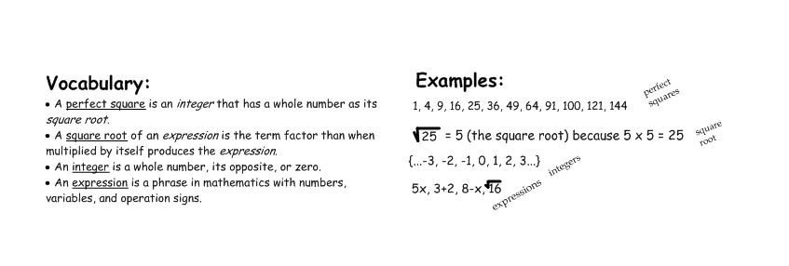

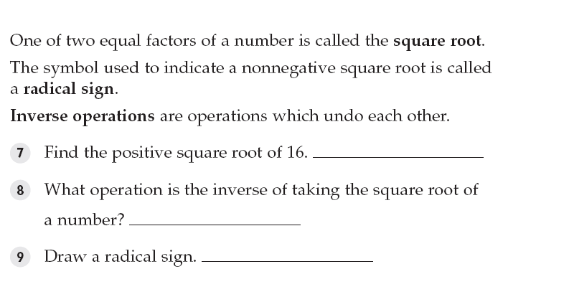

**Guided Notes:**

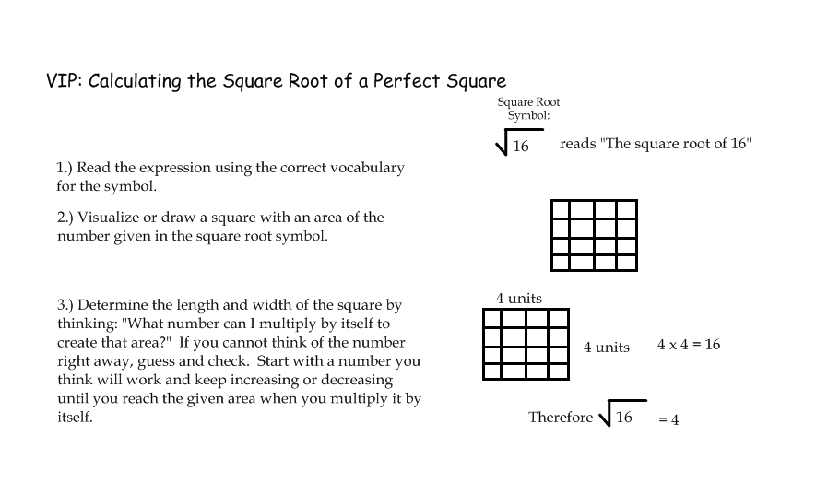

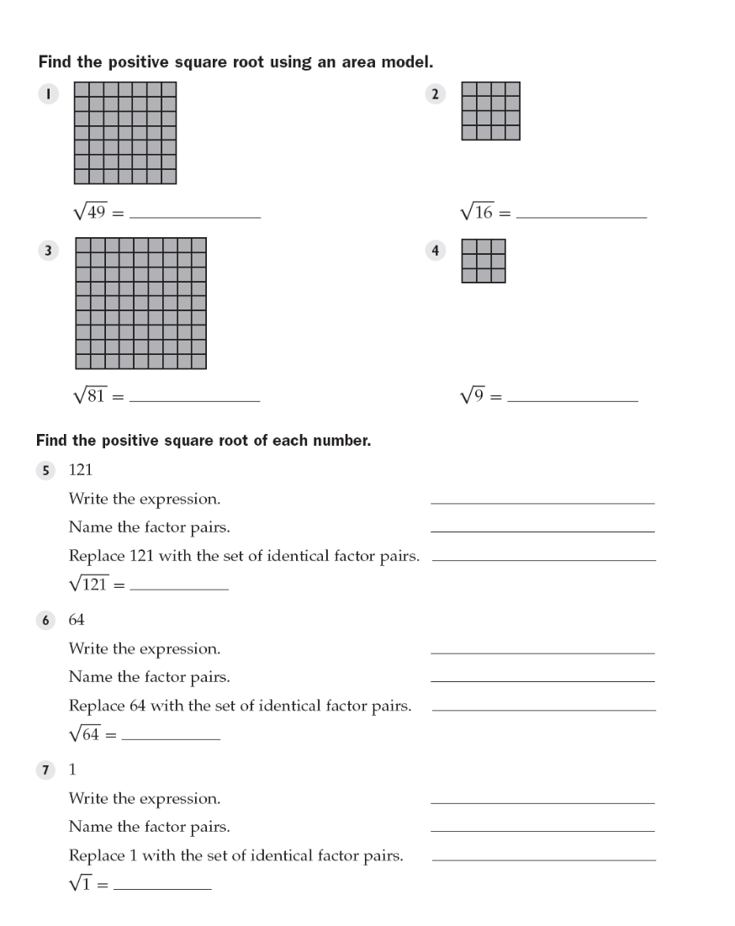

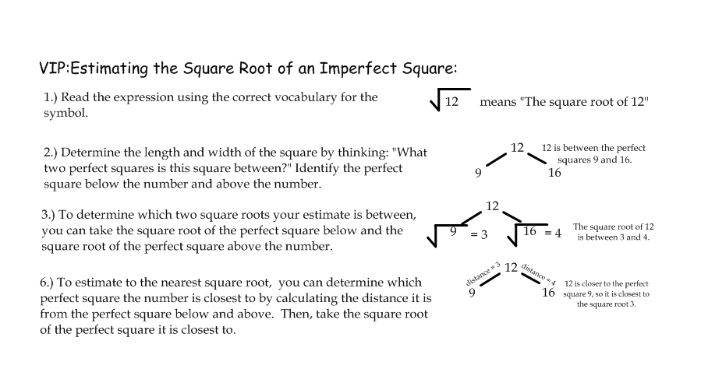

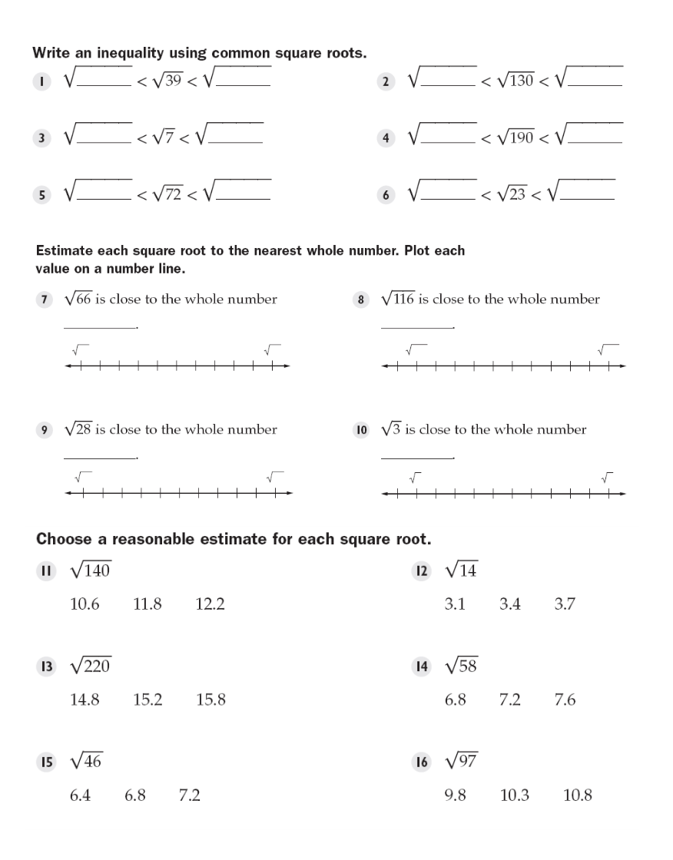

**Structured/Guided Practice:**

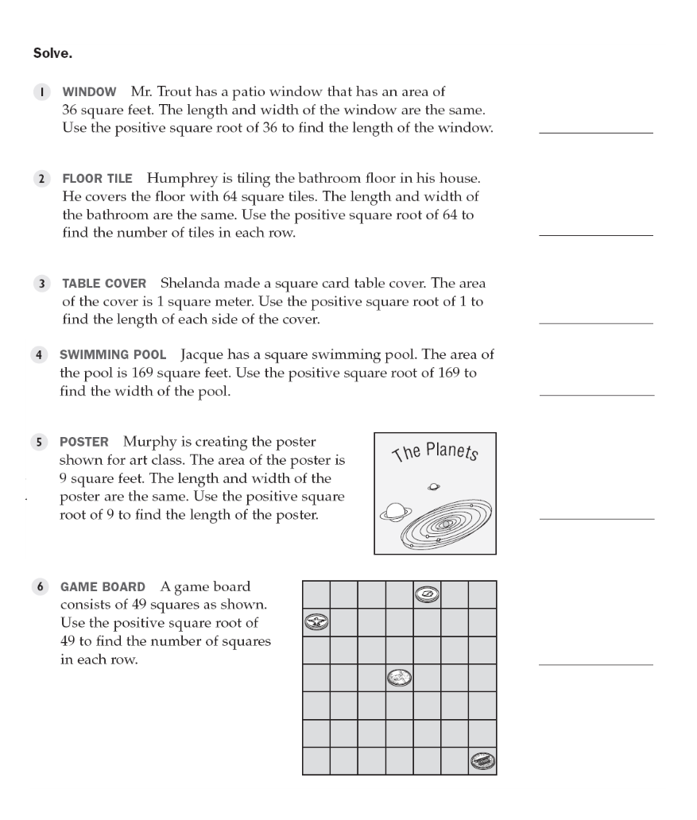

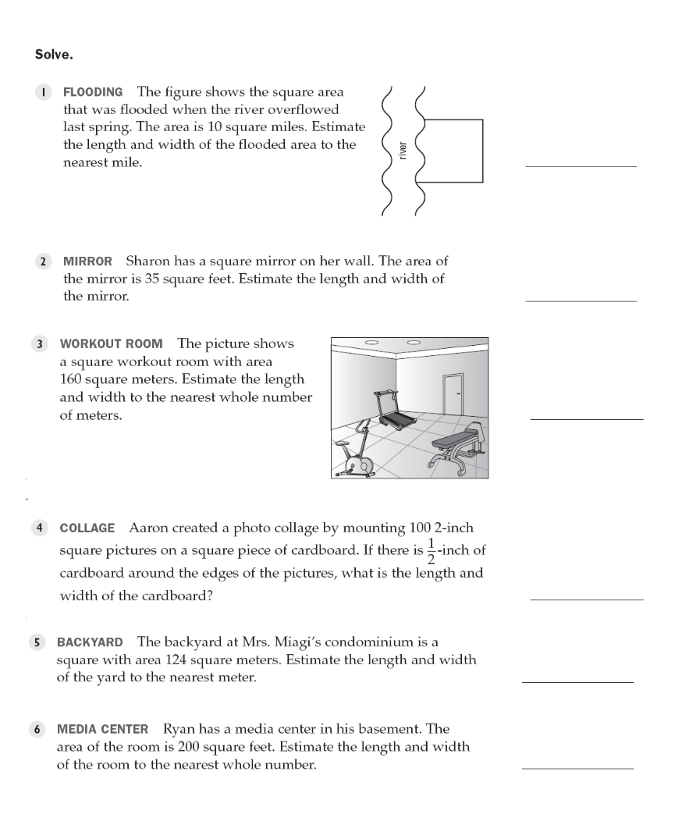

**Independent Practice:**

**Find the following square roots.**

$\sqrt{16}$

$\sqrt{225}$

$\sqrt{169}$

$\sqrt{289}$

$\sqrt{196}$

**Estimate the following square roots. Give the answer to at least the tenth’s place. Only use a calculator to check.**

$\sqrt{3}$

$\sqrt{10}$

$\sqrt{13}$